1.1 ENGLISH AND COMMUNICATION SKILLS - I
L T P
3 - 2

RATIONALE

Language is the most commonly used medium of self-expression in all spheres of human life – personal, social and professional. A student must have a fair knowledge of English language and skills to communicate effectively to handle the future jobs in industry. The objective of this subject is to enable the diploma holders to acquire proficiency, both in spoken (oral) and written language. At the end of the subject, the student will be able to develop comprehension skills, improve vocabulary, use proper grammar, acquire writing skills, correspond with others and enhance skills in spoken English. It is expected that each polytechnic will establish a communication skill laboratory for conducting practicals mentioned in the curriculum.

DETAILED CONTENTS

- Facets of Literature (14 hrs)

1.1 Short Stories

1.1.1 Homecoming – R.N. Tagore
1.1.2 The Selfish Giant - Oscar Wilde
1.1.3 The Diamond Necklace- Guy- De Maupassantt
1.1.4 The Stick – Justice Surinder Singh

1.2 Prose

1.2.1 I Have A Dream – Martin Luther King
1.2.2 On Habits – A. G. Gardiner
1.2.3 My struggle for An Education- Booker T Washington
1.2.4 Seeing People Off – Max Beerbohm

1.3 Poems

1.3.1 Ozymandias – P.B. Shelley
1.3.2 Daffodils – William Wordsworth
1.3.3 Stopping by Woods on a Snowy Evening – Robert Frost
1.3.4 Forefathers- Edmund Blunden

- Grammar and Usage (10 hrs)

  - Parts of speech

    - Nouns
    - Pronouns
    - Adjectives
    - Articles
    - Verbs
    - Adverbs
    - Prepositions
    - Conjunction
    - Interjection
    - Identifying parts of speech
    - Structures: Verb patterns, Question tags,
    - Subject – Verb agreement (concord)

2.2 Pair of words (Words commonly confused and misused)

2.3 Tenses
2.4 Correction of incorrect sentences
2.5 One word substitution

3. Translation (04 hrs)

  - Glossary of Administrative Terms (English and Hindi)
  - Translation from Hindi into English

4. Paragraph of 100-150 words from outlines (08 hrs)

5. Comprehension (04 hrs)

Unseen passages of literature, scientific data/graph based for comprehension exercises

6. Communication (08 hrs)

  - Definition, Introduction and Process of Communication
  - Objectives of Communication
  - Notices

LIST OF PRACTICALS

- Locating a Book in Library
- To look up words in a Dictionary: meaning and pronunciation of words as given in the standard dictionary using symbols of phonetics
- To seek information from an Encyclopedia
- Listening pre-recorded English language learning programme
- Paper reading before an audience (reading unseen passages)
- Study of spelling Rules
- Study of essentials of a good speech to respond and comprehend visual, oral themes, situations or stimulus and practice before select gathering
- Exercises on use of different abbreviations
- Greetings for different occasions
- Introducing oneself, others and leave taking
- Exercises on writing sentences on a topic

Note:

1. The Text Book on “English and Communication Skills, Book-I By Kuldip Jaidka et. al. developed by NITTTR, Chandigarh is recommended to be used for teaching and setting-up the question papers.
2. A communication laboratory may be set up consisting of appropriate audio-video system with facility of playing CDs/DVDs and a video camera for recording the performance of each student with play back facility. A set of CDs from any language training organization e.g. British Council etc. may be procured for use of students.
3. Elements of body language will be incorporated in all the practicals
4. The practical exercises involving writing may also be included in Theory Examination.

INSTRUCTIONAL STATREGY

Looking into the present day needs of effective communication in every field, it is imperative to develop necessary competencies in students by giving practical tips and emphasis on grammar, vocabulary and its usage in addition to practical exercises. The teacher should give report writing assignments, projects etc. while teaching this subject.

RECOMMENDED BOOKS

- English and Communication Skills, Book-I By Kuldip Jaidka, Alwainder Dhillon and Parmod Kumar Singla, Prescribed by NITTTR, Chandigarh Published By Abhishek Publication, 57-59, Sector-17, Chandigarh
- Essentials of Business Communication by Pal and Rorualling; Sultan Chand and Sons
- The Essence of Effective Communication, Ludlow and Panthon; Prentice Hall of India
- New Design English Grammar, Reading and Writing Skills by AL Kohli (Course A and course B), Kohli Publishers, 34 Industrial Area Phase-II, Chandigarh,
- New Design English Reading and Advanced Writing Skills for Class XI and XII by MK Kohli and AL Kohli; Kohli Publishers, 34 Industrial Area Phase-II, Chandigarh,
- A Practical English Grammar by Thomson and Marlinet
- Spoken English by V Sasikumar and PV Dhamija; Tata McGraw Hill
- English Conversation Practice by Grount Taylor; Tata McGraw Hill
- Developing Communication Skills by Krishna Mohan and Meera Banerji; MacMillan India Ltd., Delhi
- Business Correspondence and Report Writing by RC Sharma and Krishna Mohan; Tata McGraw Hill Publishing Company Ltd. New Delhi
- Communication Skills by R Datta Roy and KK Dhir; Vishal Publication, Jalandhar

SUGGESTED DISTRIBUTION OF MARKS

Topic No. | Time Allotted (Hrs) | Marks Allotted (%)
1 | 14 | 30
2 | 10 | 20
3 | 4 | 10
4 | 8 | 15
5 | 4 | 10
6 | 8 | 15
Total | 48 | 100

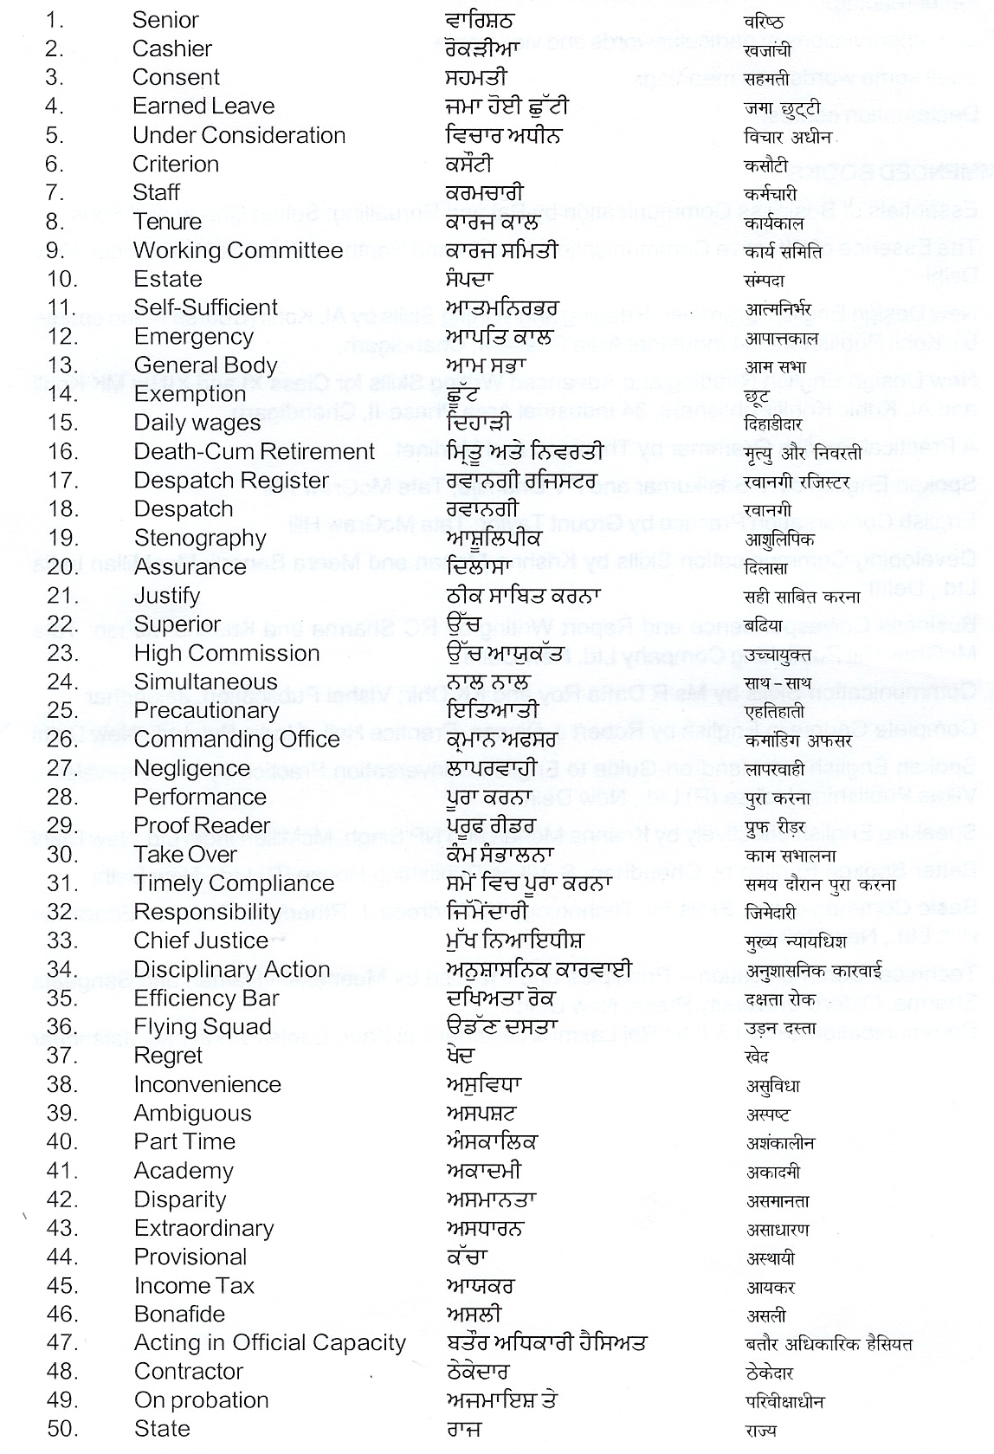
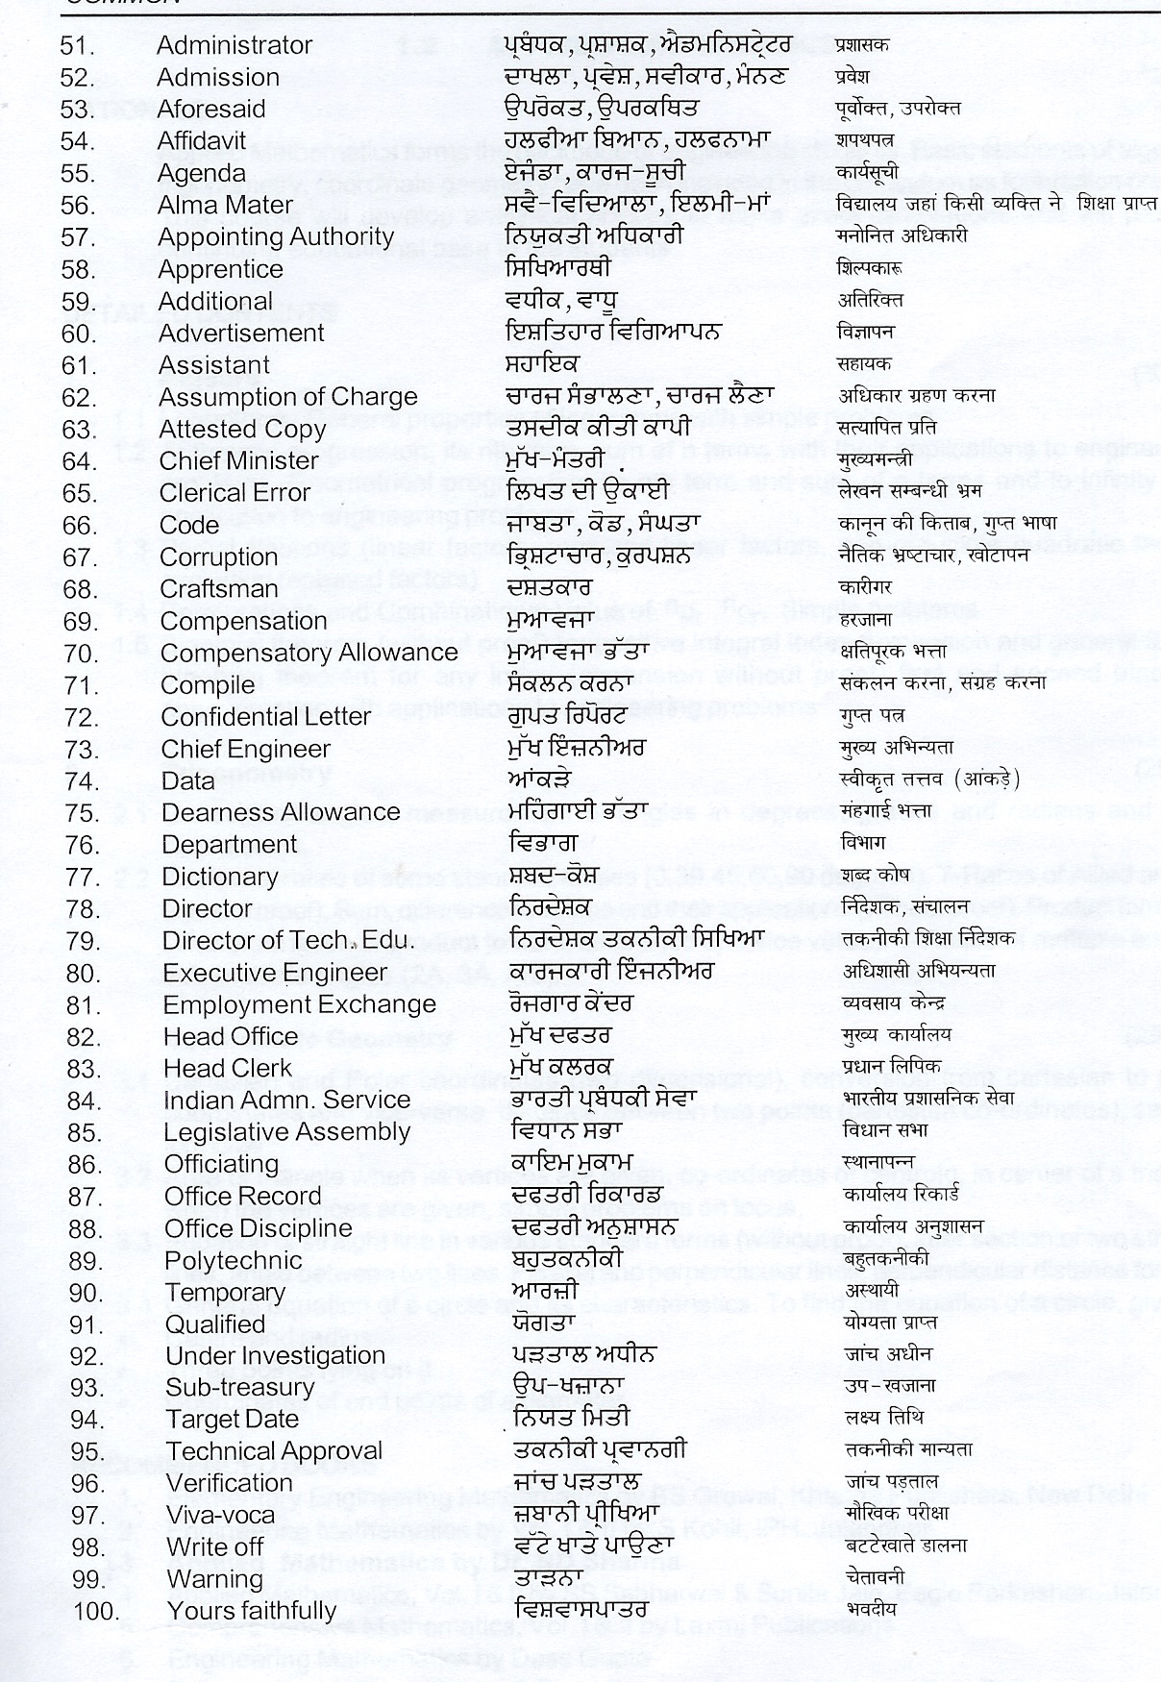
1.2 APPLIED MATHEMATICS - I
L T P
5 - -

RATIONALE
Applied Mathematics forms the backbone of engineering students. Basic elements of algebra, trigonometry, coordinate geometry have been included in the curriculum as foundation course. This course will develop analytical abilities to make exact calculations and will provide continuing educational base to the students.

DETAILED CONTENTS
1. Algebra (30 hrs)
  - Complex Numbers: Complex number, representation, modulus and amplitude. De-movier’s theorem, its application in solving algebric equation.

1.2 Geometrical progression, its nth term and sum of n terms and to infinity. Application of Arithmetic progression and Geometrical progression to Engineering problem.

  - Partial fractions (linear factors, repeated linear factors, non-reducible quadratic factors excluding repeated factors)

1.4 Permutations and Combinations: Value of npr ncr. Simple problems

  - Binomial theorem (without proof) for positive integral index (expansion and general form); binomial theorem for any index (expansion without proof) first and second binomial approximation with applications to engineering problems
2. Trigonometry (25 hrs)
2.1 Concept of angles, measurement of angles in degrees, grades and radians and their conversions.
2.2 T-Ratios of Allied angles (without proof), Sum, difference formulae and their applications (without proof). Product formulae (Transformation of product to sum, difference and vice versa). T-Ratios of multiple angles, sub-multiple angles (2A, 3A, A/2).
2.3 Graphs of Sin x, Cos x, Tan x and e^{x}

3. Co-Ordinate Geometry (25 hrs)
3.1 Cartesian and Polar coordinates (two dimensional), conversion from cartesian to polar coordinates and vice-versa, distance between two points (cartesian co-ordinates), section formulae
3.2 Area of triangle when its vertices are given, co-ordinates of centroid, in center of a triangle when the vertices are given, simple problems on locus.
3.3 Equation of straight line in various standard forms (without proof), inter section of two straight lines, angle between two lines. Parallel and perpendicular lines, perpendicular distance formula
3.4 General equation of a circle and its characteristics. To find the equation of a circle, given:
* Centre and radius
* Three points lying on it
* Coordinates of end points of a diameter

INSTRUCTIONAL STATREGY

Basic elements of algebra, trigonometry and coordinate geometry can be taught in the light of their applications in the field of engineering and technology. By laying more emphasis on applied part, teacher can also help in providing a good continuing education base to the students.

RECOMMENDED BOOKS
- Elementary Engineering Mathematics by BS Grewal, Khanna Publishers, New Delhi
- Engineering Mathematics by Vol. I & II by S Kohli, IPH, Jalandhar
- Applied Mathematics by RD Sharma
- Applied Mathematics, Vol. I & II by SS Sabharwal & Sunita Jain, Eagle Parkashan, Jalandhar
- Comprehensive Mathematics, Vol. I & II by Laxmi Publications
- Engineering Mathematics by Dass Gupta
- Engineering Mathematics by C Dass Chawla, Asian Publishers, New Delhi
- Engineering Mathematics, Vol I, II & III by V Sundaram et al, Vikas Publishing House (P) Ltd., New Delhi
- Engineering Mathematics by N.Ch., S.N Iyengar et.al, Vikas Publishing House (P) Ltd., New Delhi
- Engineering Mathematics, Vol I & II by SS Sastry, Prentice Hall of India Pvt. Ltd.,
- Engineering Mathematics, Vol I & II by AK Gupta, MacMillan India Ltd., New Delhi

SUGGESTED DISTRIBUTION OF MARKS

Topic No. | Time Allotted (Hrs) | Marks Allotted (%)
1 | 30 | 35
2 | 25 | 35
3 | 25 | 30
Total | 80 | 100

1.3 APPLIED PHYSICS – I
L T P
4 - 2
RATIONALE

Applied physics includes the study of a large number of diverse topics all related to things that go on in the world around us. It aims to give an understanding of this world both by observation and by prediction of the way in which objects will behave. Concrete use of physical principles and analysis in various fields of engineering and technology are given prominence in the course content.

DETAILED CONTENTS

1. Units and Dimensions (10 hrs)

  - Physical quantities
  - Units - fundamental and derived units, systems of units (FPS, CGS, MKS and SI units)
  - Dimensions and dimensional formulae of physical quantities
  - Dimensional equations and principle of homogeneity, applications to conversion from one system of units to another, checking the correctness of physical relations and derivation of simple physical relations, limitations of dimensional analysis
  - Significant figures and error analysis

2. Force and Motion (12 hrs)

- Scalar and vector quantities – examples, addition and multiplication (scalar product and vector product) of vectors
- Force, resolution and composition of forces – resultant, parallelogram law of forces, equilibrium of forces, Lami’s theorem
- Newton’s Laws of motion – concept of momentum, Newton’s laws of motion and their applications, determination of force equation from Newton’s second law of motion; Newton’s third law of motion, conservation of momentum, impulse, simple numerical problems
- Circular motion – angular displacement, angular velocity and angular acceleration
- Relation between linear and angular variables (velocity and acceleration)
- Centripetal force (derivation) and centrifugal force
- Banking of roads

3. Work, Power and Energy (12 hrs)

  - Work: definition and its SI units
  - Work done in moving an object on horizontal and inclined plane (incorporating frictional forces)
  - Power: definition and its SI units, calculation of power in simple cases
  - Energy: Definition and its SI units: Types: Kinetic energy and Potential energy with examples and their derivation
  - Principle of conservation of mechanical energy (for freely falling bodies), transformation of energy from one form to another
  - Concept of friction and its applications

4. Rotational Motion (06 hrs)

4.1 Definitions of torque, angular momentum, their relationship
4.2 Conservation of angular momentum (qualitative) and its examples
4.3 Moment of inertia and its physical significance, radius of gyration
4.4 Theorems of parallel and perpendicular axes (statements)
4.5 Moment of inertia of rod, disc, ring and sphere

5. Properties of Matter (12 hrs)

5.1 Elasticity, definition of stress and strain, different types of modulus of elasticity, stress – strain diagram, Hooke’s law
5.2 Pressure – its units, gauge pressure, absolute pressure, atmospheric pressure, Bourdon’s pressure manometers and barometer gauges
5.3 Surface tension – its units, measurement of surface tension by capillary tube method, applications of surface tension, effect of temperature and impurity on surface tension
5.4 Fluid motion, stream line and turbulent flow, Reynolds number
5.5 Viscosity and coefficient of viscosity, derivation of terminal velocity, effect of temperature on viscosity

6. Thermometry (12 hrs)

6.1 Principles of measurement of temperature and different scales of temperature
6.2 Difference between heat and temperature on the basis of K.E. of molecules
6.3 Types of thermometers, Physical properties on which they are based
(No description of individual thermometer)
6.4 Co-efficient of linear, surface and cubical expansions and relation amongst them
6.5 Modes of transfer of heat (Conduction, convection and radiation with examples)
6.6 Co-efficient of thermal conductivity, determination of thermal conductivity of good conductor (Searle’s method) and bad conductor (Lee’s disc method)

LIST OF PRACTICALS
- To find the diameter of wire using a screw gauge
- To find volume of solid cylinder and hollow cylinder using a vernier caliper
- To determine the thickness of glass strip and radius of curvature of a concave surface using a spherometer
- To verify the parallelogram law of forces
- To verify conservation of energy of a rolling solid sphere/cylinder
- To find the surface tension of a liquid by capillary rise method
- To determine the atmospheric pressure at a place using Fortin’s Barometer
- To determine the viscosity of glycerin by Stoke’s method
- To determine the coefficient of linear expansion of a metal rod
- To find the coefficient of thermal conductivity of copper using Searle’s conductivity apparatus
- To find the coefficient of thermal conductivity of bakelite sheet (bad conductor) by Lee’s Disc Method

INSTRUCTIONAL STATREGY

Teacher may use various instructional aids like models, charts, graphs and experimental kits etc. for imparting instructions in the subject. The field applications should be made clear before teaching the basics of mechanics, work power and energy, rotational motion, properties of matter etc. to develop proper understanding of the physical phenomenon. Use of demonstration can make the subject interesting and develop scientific temper in the students.

RECOMMENDED BOOKS
- Test Book of Physics for Class XI (Part-I, Part-II) N.C.E.R.T
- Test Book of Physics for Class XII (Part-I, Part-II) N.C.E.R.T
- Applied Physics, Vol. I and Vol. II, TTTI Publications, Tata McGraw Hill, Delhi
- Concepts in Physics by HC Verma, Vol. I & II, Bharti Bhawan Ltd. New Delhi
- Fundamentals of Physics by Resnick and Halliday & Walker, Asian Book Pvt. Ltd., New Delhi
- Berkeley Physics Course, Vol. I, II &III, Tata McGraw Hill, Delhi
- The Feynman Lectures on Physics by Feynman, Leighton and Sands, Vol. I & II, Narosa Publishing House, Delhi
- Fundamentals of Optics by Francis A. Jenkins & Harvey E White, McGraw Hill International Editions, Physics Series
- A Text Book of Optics by Subramanian and Brij Lal, S Chand & Co., New Delhi
- Comprehensive Practical Physics, Vol, I & II, JN Jaiswal, Laxmi Publishers
- Engineering Physics by PV Naik, Pearson Education Pvt. Ltd, New Delhi
- Applied Physics I & II by RA Banwait & R Dogra, Eagle Parkashan, Jalandhar

SUGGESTED DISTRIBUTION OF MARKS
Topic No. | Time Allotted (Hrs) | Marks Allotted (%)
1 | 10 | 10
2 | 12 | 20
3 | 12 | 20
4 | 06 | 10
5 | 12 | 20
6 | 12 | 20
Total | 64 | 100
1.4 APPLIED CHEMISTRY-I
L T P
4 - 2

RATIONALE

The role of chemistry and chemical products in every branch of engineering is expanding greatly. Now a days various products of chemical industries are playing important role in the field of engineering with increasing number of such products each successive years. The strength of materials, the chemical composition of substances, their behavior when subjected to different treatment and environment, and the laws of heat and dynamic energy have entered in almost every activity of modern life. Chemistry is considered as one of the core subjects for diploma students in engineering and technology for developing in them scientific temperament and appreciation of chemical properties of materials, which they have to handle in their professional career. Effort should be made to teach this subject through demonstration and with the active involvement of students.

DETAILED CONTENTS

1. Basic concepts of Chemistry (10 hrs)

1.1 Units and Dimensions, derived units (with special reference to pressure, volume, temperature, density, specific gravity, surface tension, viscosity and conductivity)
1.2 Matter, element, compound and mixtures, atom, molecule, ion, symbols and formulae (recapitulation only)
1.3 Atomic mass (A), molar mass, mole concept, molar volume of gases
1.4 Solution, strength of solutions in grams per liter, molarity (M), molality (m), mass fraction and mole fraction
1.5 Chemical equations, thermo-chemical equations, balancing of chemical equations
  - Numerical problems based on mole concept.

2. Atomic structure and Chemical Bonding (10 hrs)

2.1 Fundamental particles i.e. electron, proton and neutron (their masses and charges)
2.2 Postulates of Bohr model of atom, success and failures of Bohr model of atom
2.3 Heisenberg’s uncertainty principle
2.4 Elementary idea of modern concept of atom, quantum numbers (significance only), definition of shells, sub shells and orbitals, shapes of s & p orbitals only. Electronic configuration of elements (atomic number 1 to 30 only) on the basis of Aufbau principle, Pauli’s principle and Hund’s rule
2.5 Modern periodic law, introduction of periodic table, periods and groups,
2.6 Division of the periodic table into s, p, d, and f blocks (details excluded)
2.7 Chemical bond and cause of bonding
2.8 Ionic bond, covalent bond, orbital concept of covalent bonding, valence bond theory, sigma (σ) and pi (π) bonds.
2.9 Metallic bonding (electron sea model)
2.10 Coordinate bond with examples of ozone, ammonium chloride, H₃N-BF₃ complex

3. Water (12 hrs)

  - Sources of water
  - Hard water, soft water, types of hardness, action of soap on hard water
  - Degree of hardness in terms of calcium carbonate, Units of hardness in Clark degree, French degree and ppm
  - Estimation of hardness by EDTA method,
  - Disadvantages of hard water in domestic and industrial uses
  - Boiler water: causes and prevention of scale and sludge formation, corrosion, priming & foaming and caustic embitterment
  - Softening of hard water by premutit and ion exchange processes
  - Qualities of drinking water and purification of available water for drinking purposes
  - Chemical analysis: Estimation of alkalinity, estimation of total dissolved solids (TDS), free chlorine, chloride, and dissolved oxygen
  - Numerical problems

4. Equilibrium, Acids and Bases. (12 hrs)

4.1 Equilibrium state, equilibrium constant and statement of Le-chatelier’s principle with illustration
4.2 Ionization of electrolyte in aqueous solution, ionic equilibrium, degree of ionization, self-ionization of water and ionic product of water (K_{w})
4.3 Concept of pH and pH scale
4.4 Arrhenius concept of acids/bases; strong acids/bases, weak acids/bases, dissociation constants of acids/bases. Neutralization, acid base titration, choice of indicators for acid base titration
4.5 Hydrolysis of salts, buffer solutions (acidic and basic), buffer action of a buffer solution, applications of buffer solution
4.6 Simple numerical problems

5. Electrochemistry. (12 hrs)

5.1 Electronic concept of oxidation and reduction, redox reactions
5.2 Electrolytes and non electrolytes
5.3 Electrolysis, Faradays laws of electrolysis
5.4 Applications of electrolysis in electrometallurgy, electro-refining and electroplating
5.5 Galvanic cells (elementary idea) brief description of Daniel cell, Ni-Cd cell, dry cell and lithium iodide cell
5.6 Lead storage batteries and maintenance free batteries
5.7 Simple numerical problems related to Faraday’s laws

6. Organic Chemistry.
(08 hrs)
6.1 Tetra covalency of carbon, catenation (definition only)
6.2 Structural and condensed formulae of organic compounds
6.3 Homologous series, functional groups and following organic families:
(a) alkanes (b) alkenes (c) alkynes (d) alcohols (e) ethio-alcohals (f) ethers (g) aldehydes and ketones (h) Carboxylic acids (i) esters (j) amides (k) amines thio-alcohols (l) cyanides (m) ethers (with structure and IUPAC names of first two members only)

LIST OF PRACTICALS

1. Introduction to volumetric analysis, apparatus used and molarity based calculations

- To determine strength of given solution of sodium hydroxide by titrating against standard solution of oxalic acid using phenolphthalein indicator.

- To determine strength of given solution of sulphuric acid by titrating against standard solution of sodium carbonate using methyl orange indicator (or by conductometrically).

- To analyse commercial samples of antaacids by determining the amount of HCl they can neutralize.

- Estimation of hardness of water by EDTA method.

- Estimation of total alkalinity in the given sample of water by titrating against standard solution of sulfuric acid.

- Determination of the dosage of bleaching powder required for sterilization or disinfection of different samples of water, using standard sodium thiosulfate solution

- Estimation of chloride ions in the given sample of water by titrating against standard solution of silver nitrate.

- To determine %age purity of ferrous sulphate in given solution of known strength using potassium permanganate solution.

- To distinguish between aldehyde and ketone by Tollen’s reagent (benzaldehyde and acetone may be used)

- To verify the first law of electrolysis. (Electrolysis of copper sulphate solution using copper electrode).

- To prepare iodoform from ethanol or acetone

- To prepare the Mohr’s salt from ferrous sulphate and ammonium sulphate.

INSTRUCTIONAL STATREGY

Teacher may take help of various models and charts while imparting instructions to make the concepts clear. More stress may be laid on practical applications of various chemical processes and reactions. In addition, students should be encouraged to study those processes in more details, which may find practical applications in their future professional life.

RECOMMENDED BOOKS

- Chemistry in Engineering by J.C. Kuricose And J. Rajaram, Tata McGraw Hill, Publishing Company Limited, New Delhi.

- Engineering Chemistry byt P.C.Jain and Monika Jain, Dhanapat Rai Publishing Company New Delhi.

- Engineering Chemistry by Shashi Chawla.

- Progressive Applied Chemistry – I by Dr. G.H. Hugar Eagle Prakashan Jalandhar

SUGGESTED DISTRIBUTION OF MARKS

Topic No. | Time Allotted (Hrs) | Marks Allotted (%)
1 | 10 | 15
2 | 10 | 15
3 | 12 | 20
4 | 12 | 20
5 | 12 | 20
6 | 08 | 10
Total | 64 | 100

1.5 ENGINEERING DRAWING - I
L T P
- - 7
RATIONALE

Drawing is the language of engineers and technicians. Reading and interpreting engineering drawing is their day to day responsibility. The subject is aimed at developing basic graphic skills in the students so as to enable them to use these skills in preparation of engineering drawings, their reading and interpretation. The emphasis, while imparting instructions, should be to develop conceptual skills in the students following BIS SP 46 – 1988.

Note:
i) First angle projection is to be followed
ii) Minimum of 16 sheets to be prepared
iii) Instructions relevant to various drawings may be given along with appropriate demonstrations, before assigning drawing practice to students

DETAILED CONTENTS

1. Handling, Use and Care of Drawing Instruments and Materials

1.1 Drawing Instruments
1.2 Materials
1.3 Layout of drawing sheets

2. Free Hand Sketching and Lettering (02 sheets)

2.1 Different types of lines in Engineering drawing as per BIS specifications
2.2 Practice of free hand sketching of vertical, horizontal and inclined lines, geometrical figures such as triangles, rectangles, circles, ellipses and curves

3. Lettering Technique and Practice (02 sheets)

3.1 Instrumental single stroke lettering of 35 mm and 70 mm height in the ratio of 7:4
3.2 Free hand lettering (Alphabet and numerals )- lower case and upper case, single stroke, vertical and inclined at 75 degree in different standards, series of 3, 5, 8 and 12 mm heights in the ratio of 7:4

4. Dimensioning Technique (01 sheet)

4.1 Necessity of dimensioning, method and principles of dimensioning (mainly theoretical instructions)
4.2 Dimensioning of overall sizes, circles, threaded holes, chamfered surfaces, angles, tapered surfaces, holes, equally spaced on P.C.D., counter sink holes, counter bored holes, cylindrical parts, narrow spaces and gaps, radii, curves and arches

5. Scales (02 sheets)

5.1 Scales - their need and importance (Theoretical instructions).
5.2 Drawing of plain and diagonal scales

6. Projection (04 sheets)

6.1 Theory of projections ( Elaborate theoretical instructions)
6.2 Drawing 3 views of given objects (Non-symmetrical objects may be selected for this exercise)
6.3 Drawing 6 views of given objects (Non-symmetrical objects may be selected for this exercise)
6.4 Identification of surfaces on drawn views and objects drawn
6.5 Exercises on missing surfaces and views
6.6 Introduction to third angle projections

7. Sections (02 sheets)

7.1 Importance and salient features, Methods of representing sections, conventional sections of various materials, classification of sections, conventions in sectioning
7.2 Drawing of full section, half section, partial or broken out sections, Offset sections, revolved sections and removed sections.
7.3 Drawing of different conventions for materials in section, conventional breaks for shafts, pipes, rectangular, square, angle, channel, rolled sections
7.4 Exercises on sectional views of different objects.

8. Isometric Views (02 sheets)

8.1 Fundamentals of isometric projections (Theoretical instructions)
8.2 Isometric views from 2 or 3 given orthographic views.

9. Symbols and Conventions (02 sheets)

9.1 Civil engineering, sanitary fitting symbols
9.2 Electrical fitting symbols for domestic interior installations
9.3 Building plan drawing with electrical and civil engineering symbols

10. Preparation of simple working drawing of furniture items like table, stool and any job prepared in the workshop. (01 sheet)

RECOMMENDED BOOKS

1. A Text Book of Engineering Drawing by Surjit Singh, Dhanpat Rai & Co., Delhi
2. Engineering Drawing by PS Gill, SK Kataria & Sons, New Delhi

3. Elementary Engineering Drawing in First Angle Projection by ND Bhatt, Charactar Publishing House
4. Engineering Drawing I & II by JS Layall, Eagle Parkashan, Jalandhar

1.6 WORKSHOP PRACTICE
L T P
- - 8

RATIONALE
This course aims at developing generic manual and machining skills in the students. Besides above the development of dignity of labour, precision, safety at work places, team working and development of right attitude are other objectives.

DETAILED CONTENTS
The following shops are included in the syllabus :
1. Carpentry and Painting shop
2. Fitting shop
3. Welding shop
4. Electric shop
5. Smithy shop
6. Mechanical Shop
1. Carpentry and Painting Shop
1.1 Introduction to various types of wood by demonstration and their identification.
1.2 Demonstration, function and use of commonly used hand tools. Care, maintenance of tools and safety measures to be observed.
Job I Marking,sawing and planning practice
Job II Extensive planning practice
Job III Chiseling practice
1.3 Introduction to joints, their relative advantages and uses.
Job IV Preparation of half lap joint
Job V Preparation of Mortise and Tenon Joint
1.4 Importance and need of polishing wooden items, Introduction to polishing materials.
Job VI Preparation of surface before polishing.
Job VII Application of primer coat.
Job VIII Polishing on wooden items.
2. Fitting Shop
2.1 Introduction to fitting shop, Common materials used in fitting shop, Identification of materials.
2.2 Description and demonstration of various types of work benches. Holding devices and files, Precautions while filing
Job I Filing practice (Production of flat surfaces) Checking by straight edge.
Job II Marking of jobs, use of marking and measuring tools.

Job III Filing a dimensioned rectangular or Square piece of an accuracy of +0.25mm.
2.3 Introduction to chipping, Demonstration on chipping and its applications. Demonstration and function of chipping tools.
Job IV Chipping practice
2.4 Description & demonstration Simple operation of hacksawing, demonstration and description of various types of blades, their uses and method of fitting the blade.
Job V Making a cutout from a square piece of iron block using hacksaw.
3. Welding Shop
3.1 Introduction to welding and its importance in engineering practice; types of welding; common materials that can be welded.
3.2 Electric arc welding, (AC and DC) precautions while using electric arc welding, Practice in setting current and voltage for striking proper arc.
Job I Practice of striking arc while using electric arc welding set.
Job II Welding practice job on arc welding for making uniform and straight weld beads.
3.3 Common welding defects and inspection.
3.4 Various types of joints and end preparation.
Job III Preparation of butt joint arc welding.
Job IV Preparation of lap joint by arc welding.
Job V Preparation of single V/double V butt joint by using electric arc welding.
Job VI Preparation of Tee joint by arc welding.
4. Electric Shop
4.1 Study, demonstration and identification of common electrical materials such as wires, cables, switches, fuses, ceiling roses, battens, cleats and allied items, tools and accessories.
4.2 Study of electrical safety measures and demonstration about use of protective devices.
Job I Identification of phase, neutral and earth of domestic appliances and their connection to two pin/three pin, plugs.
Job II Laying out of complete wiring of a house (i) batten wiring (ii) plastic casing and capping.
4.3 Study of common electrical appliances such as electric irons, electric kettles, electric water heaters, table fans and electric mixer.
Job III Testing and rectification of simulated faults in above said electrical appliances.
4.4 Introduction to a battery and its working.
Job IV Charging a battery and testing it with the help of hydrometers and cell testers.
Job V Installation of battery connections in series and parallel
5. Smithy Shop
5.1 Demonstration and detailed explanation of tools and equipment used. Forging operations in Smithy shop. Safety measures to be observed in the smithy shop.
5.2 Demonstration and description of bending operation using tools viz Blowers, pressure blowers ( hand and power operated) upsetting operation, description and specification of anvils, swage blocks, hammers
5.3 Demonstration and description of tongs, fullers, swages
Job I To forge a L-Hook.
Job II Upsetting at ends only.
Job III Preparation of lap joint for rivetted joint, caulking and and fullering.
Job IV To prepare a lap rivetted joint.
Job V To forge a chisel and acquaint the students with forge welding.
6. Mechanical Shop
6.1 Bearings & Lubricants
Job I Study of various types of bearings bush, ball, rollers, thrust
Bearings; their demonstration and applications in Textile machinery.
Job II Study of various types of lubricants and their properties .
Job III Demonstration of various methods of lubrication and
Selection of Lubricants
6.2. Boilers
Study of Steam Properties and knowledge of wet, dry and super heated
steam
Steam Traps, Reducer and steam radiators
Job IV Study and demonstration of water tube and fire tube boiler
Job V Study of various boiler mountings and accessories

RECOMMENDED BOOKS
1. Manual on Workshop Practice by K Venkata Reddy, KL Narayana and P Kaunaioh; MacMillan India Ltd., New Delhi
2. Basic Workshop Practice Manual by T Jeyapoovan; Vikas Publishing House (P) Ltd., New Delhi

